**Department of Computer Science and Engineering**

**University of Liberal Arts Bangladesh**

**Mid-Term Examination (Summer 2020)**

**Course: Automata and Theory of Computation (CSE 417)**

**Section: 2 --- Duration: 1 Hour**

**______________________________________________________________________________________**

**PLEASE ANSWER ALL QUESTIONS. Total 25 Marks**

**QUESTION 1**

What are the 5-tuples of a DFA?

What is the difference between the formal definitions of DFA, NFA and Ɛ-NFA? Explain with a suitable example. **(2+3=5 Marks)**

**QUESTION 2**

Consider the following Ɛ-NFA:

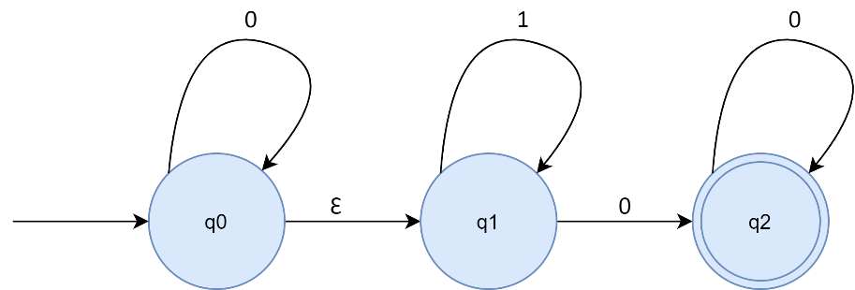

Convert the Ɛ-NFA to its equivalent NFA.

What will be the output for inputs “000” and “111”? **(3+2=5 Marks)**

**QUESTION 3**

Define the transition function, δ for an NFA.

“All DFAs are by definition an NFA”- Explain

Suppose you are trying to develop a game where the user starts from the center (0,0) of a standard cartesian coordinate system. The user can either move up (denoted by U/↑) or he can move right (denoted by R/→). Assume the user wins the game if s/he reaches (2,1). Design the NFA that can determine if the user wins the game. Provide, Q, Σ, q0, and F. **(1+2+4=7 Marks)**

**QUESTION 4**

Prepare the state transition table for the NFA you designed. Convert it to its equivalent DFA.

How would you convert a DFA to its equivalent NFA?

Is it possible for a DFA to have more than one final state? **(5+2+1=8 Marks)**

**\*\*END OF QUESTIONS\*\***